**RapidMiner GenAI Demo Details**

**Tools Used:**

1. RapidMiner Studio 10.3
2. Rapidminer AI Hub 10.1
3. Pinecone Vector DB
4. Streamlit
5. Github

**Architecture:**

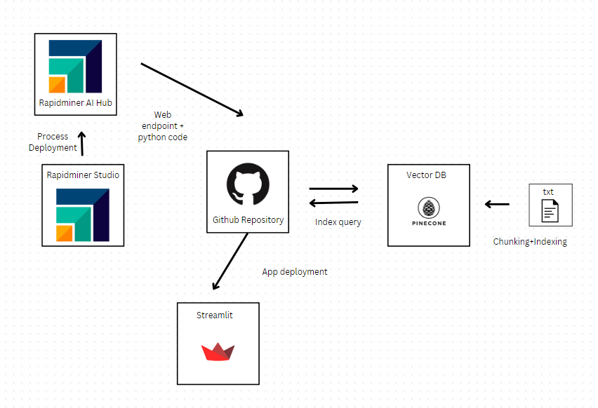

**Flow:**

1. Data scraped from web is stored in txt document.
2. This document is preprocessed, broken down into chunks, and stored in Pinecone Vector DB as embedding vectors.
3. A Python executor operator calls the OpenAI chat completion model, that accepts prompts and retrieved indexes from the pinecone vector to generate answers based on the users query.
4. The process is saved and deployed on Rapidminer AI Hub.
5. The endpoint of the deployment is used to send prompts and recieve generated answers, which are then integrated with the streamlit frontend app deployment, whose code is launched on github.